GL Soft Close now allows users with an Advanced GL or Enterprise Ledger license to soft close a General Ledger (GL) period for a specific entity or entities, so that only users with sufficient access can enter transactional data and journal entries in that period.
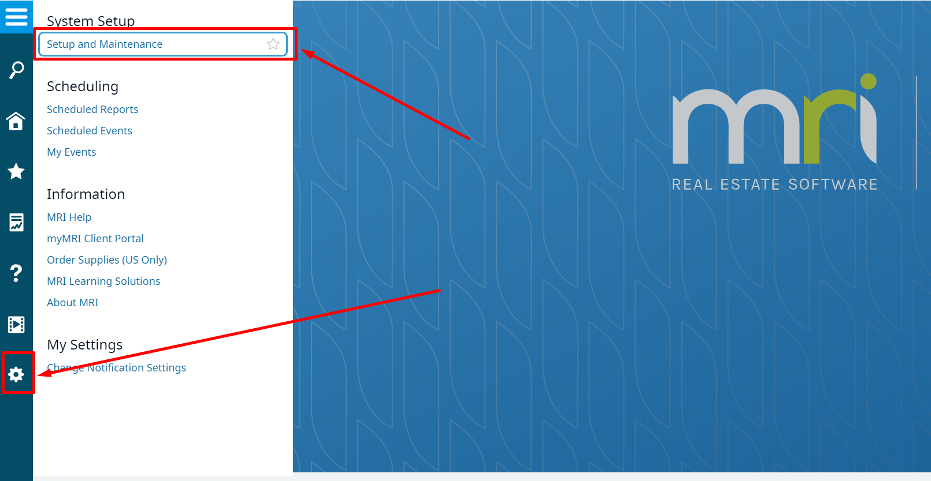
Ready to take advantage of this brand new feature? Let’s go!
First, click on the Gear Icon, then on Setup and Maintenance.

Then, under Management Options, Click on General Ledger.
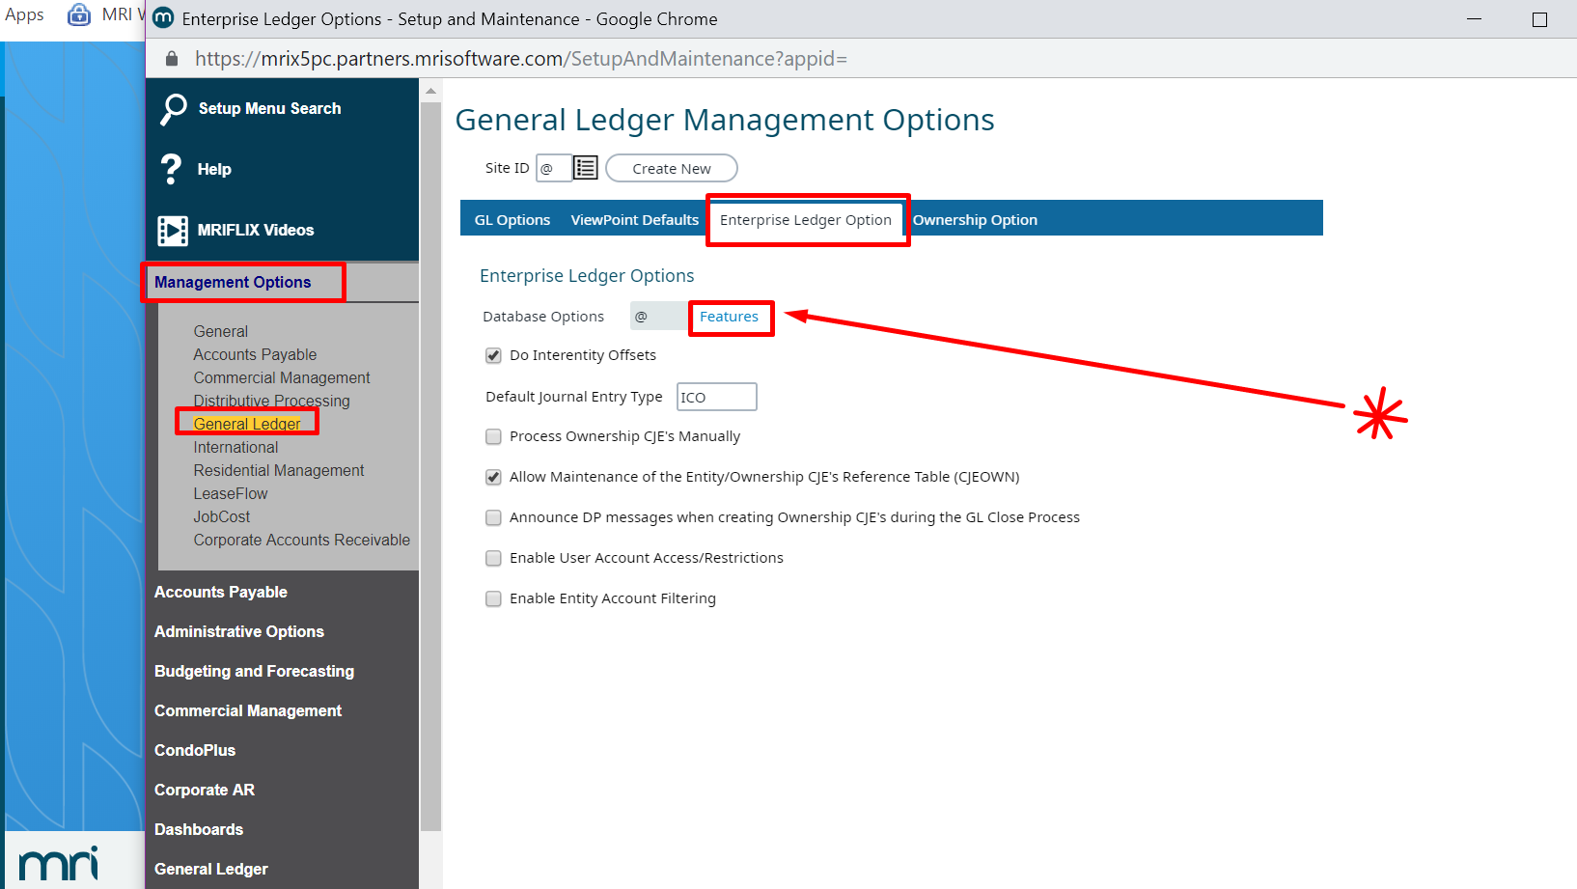
Under Enterprise Ledger Options, click on Features
Here you will be able to enable the Soft Close Period link in the Closing Procedures section!
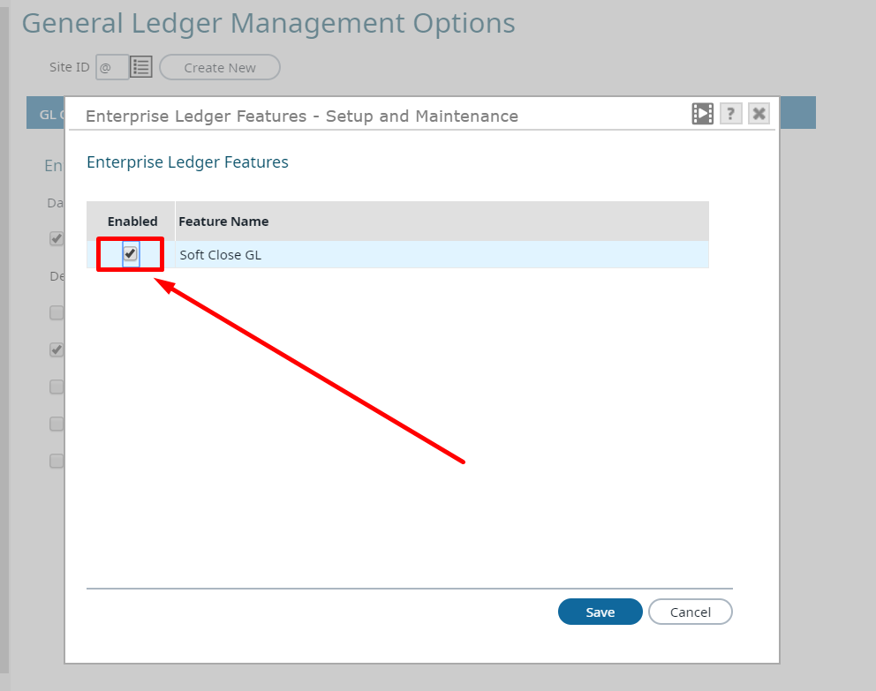

Note
The following access options in the security console for the Advanced GL application MUST be provided for use of the Soft Close page:
- EDTSFTCLSGL – Allows THE USER TO Create and edit Journal Entries for a soft closed GL period.
- SOFTCLOSEGL – Allows the user to soft close and unclose an Entity for its current GL period.

For more information about soft closing a GL period, refer to the “Soft Closing GL Periods” topic in the web Help (General Ledger (GL) > Closing > Soft Closing GL Periods).

