In MRI for the Web, users can now email a combined report batch as a PDF attachment to a list of email recipients!
First, click on the Reports Icon, then on Report Batches.
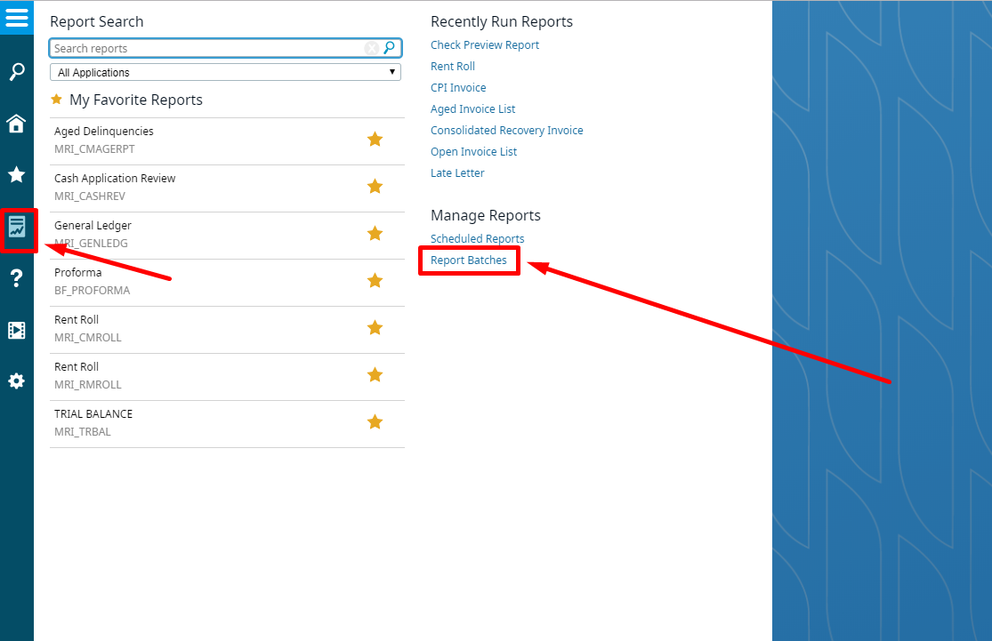

Then, click New Report Batch.
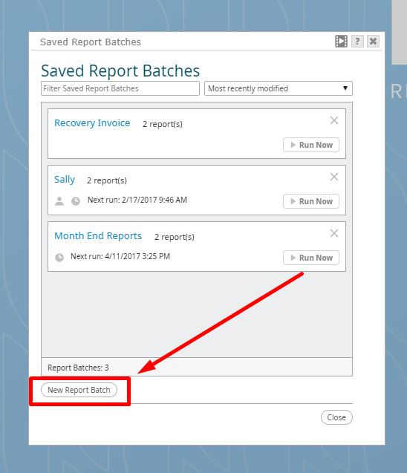
Enter in your new reports information, and check the Combine reports into one PDF box!
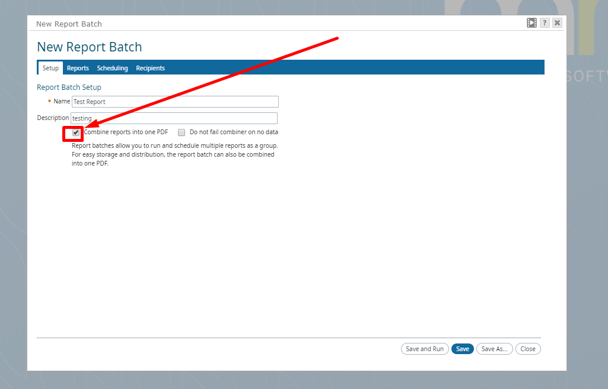

Once you do, a new Recipients tab will be added, where you can further customize your email settings and list of recipients
