Executive Dashboards

Are you familiar with MRI’s Executive Dashboards? Would you like to be able to view property and financial data for your properties at a consolidated level all on one screen? The Executive Dashboard allows you to view operational data, occupancy, aging, lease expirations and financial data for properties at a project, portfolio, region or asset manager level. This dashboard is a great tool for those in your organization that don’t access the system daily but want quick and easy up to date information.
Click here to view some of the features of dashboard

Main View

- High level view of operational data
- Ability to drill down on properties and view lease data and property specific data
- Occupancy view
- Quick links to views and reports
- Financial data comparison with account groups you create
- Personalize with your logo

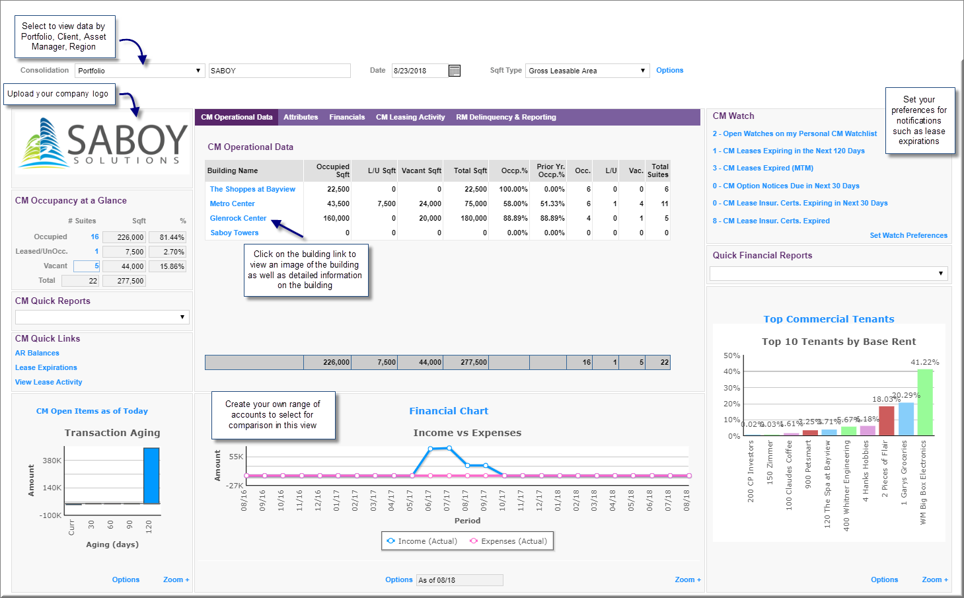

Building View

- Property specific data
- Quick links to views and reports
- Watchlist options
- Upload image of property

