Would you prefer to search for leases by Occupant Name instead of Lease ID? How about searching for a vendor by Vendor Name instead of Vendor ID?
Take advantage of MRI’s powerful Lookup Suggestion Feature.
To set your lookup preferences, click on your name in the bottom right corner of the MRI main menu. Then click on My Preferences.
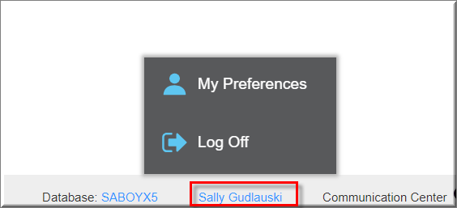

Next, click on the Advanced option on the left and click on Lookup Suggestion Columns. Scroll to the value you want to change. For example, to change the lookup filter for Lease, scroll to LEAS.
Next, type in the name of the field you wish to search on. In the example below, we want to search by the Occupant Name. The name of this field is OCCPNAME.
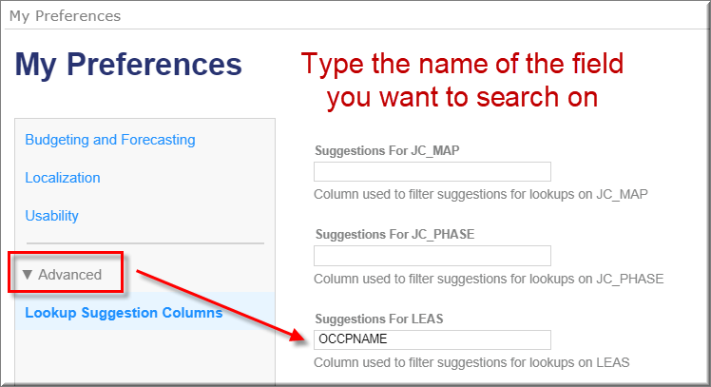

When entering cash receipts or performing other batch activities, you can now type the occupant name instead of the lease ID.
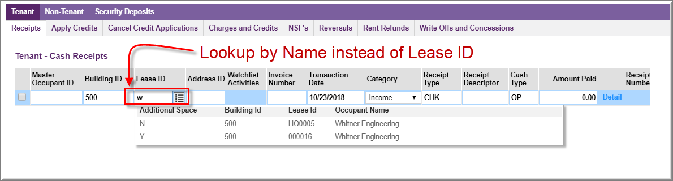

This will also work in other areas in MRI such as reporting.
