MRI X.5 Features

MRI Software has just released its latest version - X.5 and it's filled with some great features. In this document, we have listed a few of the new features but there are many more!

Favoriting Menu Items

Now in addition to the ability to favorite reports, you can favorite menu items.

- Hover over a menu item
- Notice the outline of a star will appear
- Click the star to add it as a favorite. It will become a gold star.

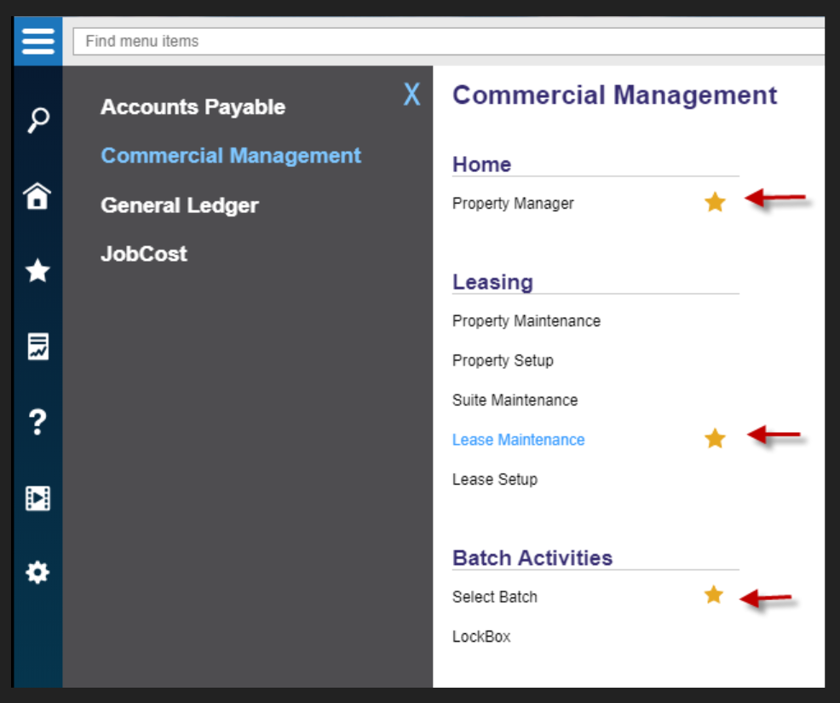

- MRI has added a new icon for favorites. Once you favorite a menu item, it will show up on the newly added menu star icon on the left panel.

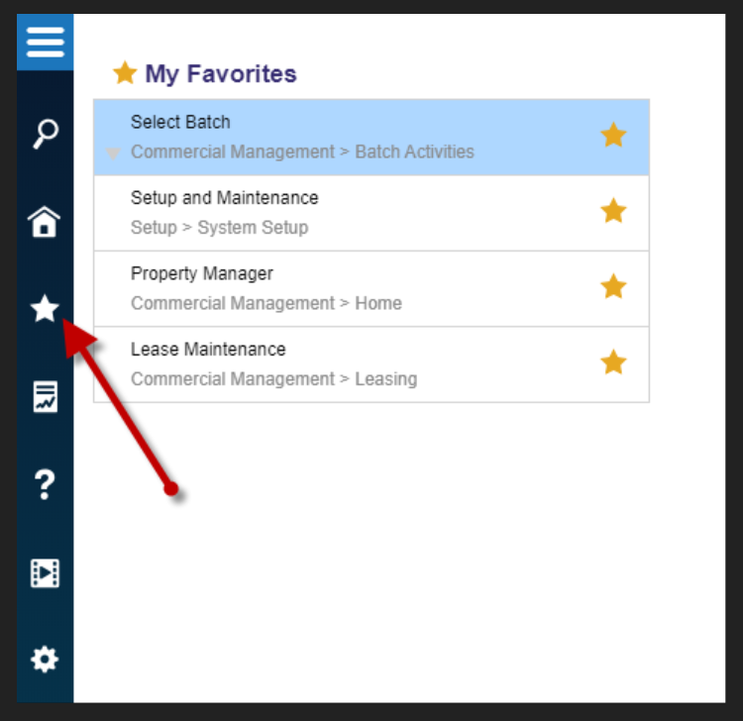

Advanced Report Filtering

The Advanced filtering option is back! X.5 gives you the ability to further refine data results by adding a filter to your reports.

- On any report, there is an Advanced Filtering link.

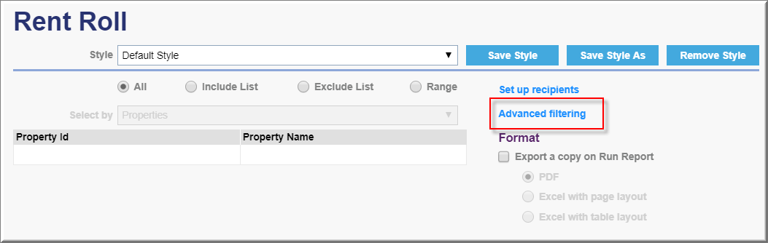

- Once you click on this link, you have the ability to add one or more filters.

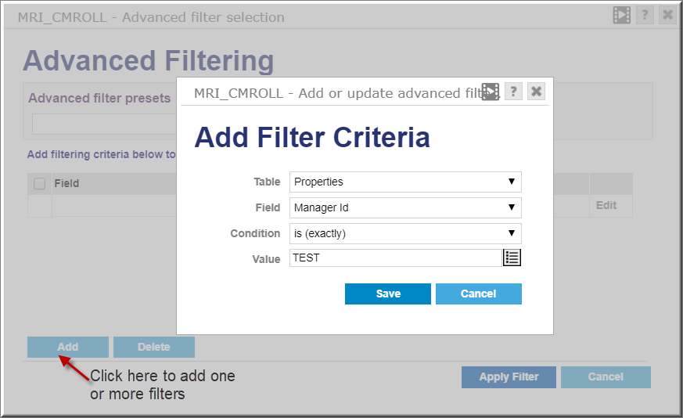

- After clicking Save, you can give the filter a name and save the filter for future use by clicking the Save As button.
- MRI also allows you to flag the filter as Private so that it is only accessible to your user ID.

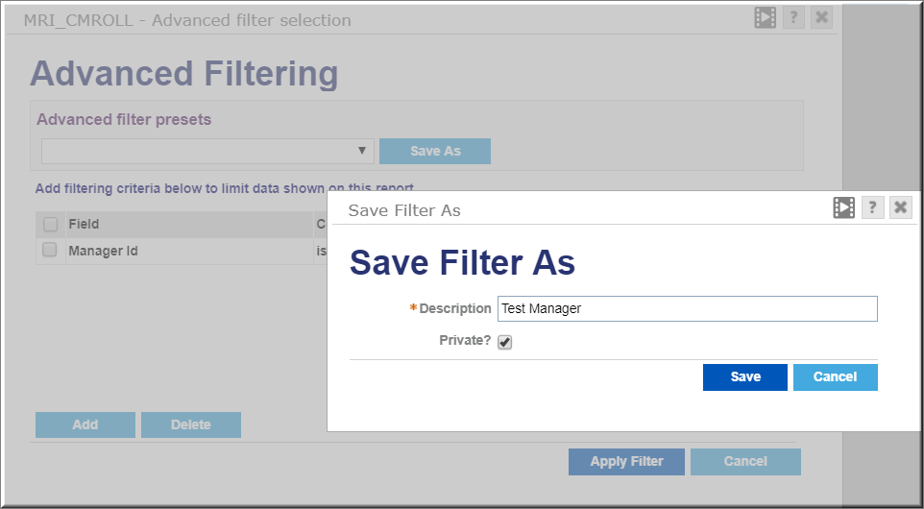

New Rebranded Reports

MRI has released new versions of existing reports in version X.5. The reports are the same but they have been reformatted for a more professional look.

- To view these reports, simply type MRIX in the report search field. All of the rebranded reports will display.
- Run the report like you normally would by filling out the runtime options.

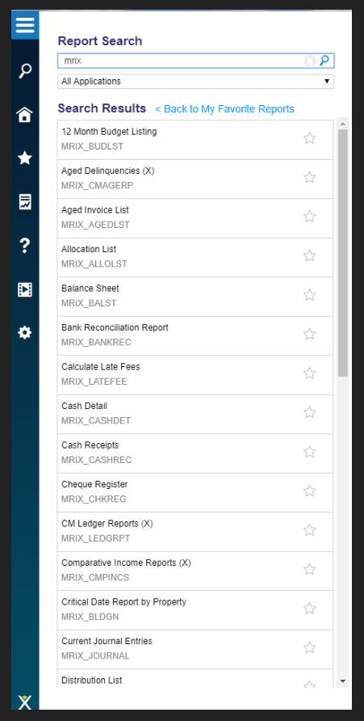

- The new reports contain stylish new headings.

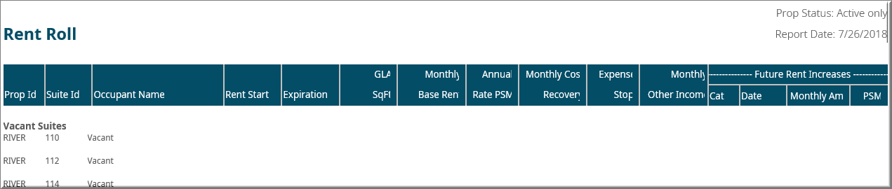

Contact Saboy to learn about these and many more awesome new features available on MRI X.5!

Phone: 315-765-6150
Email: info@saboysolutions.com

